**NEWER:** UJJWAL KUMAR

**NEWER ID :** 4161

**EMAIL :** [Ujjwal.kumar@tothenew.com](mailto:Ujjwal.kumar@tothenew.com)

1)Create Database

ANS: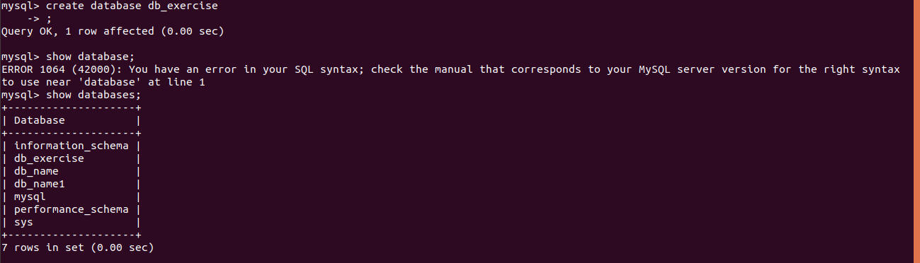

2)Design Schema

ANS:

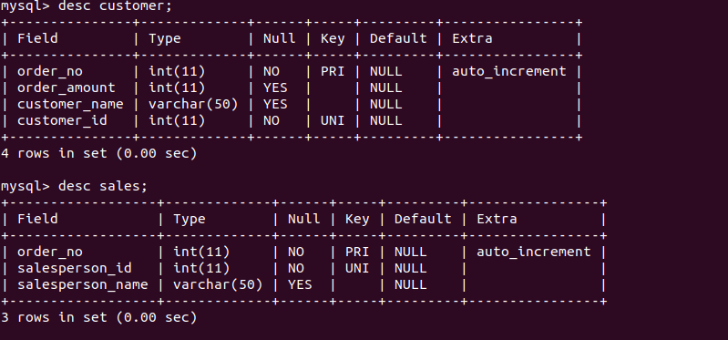

3)Create tables

ANS:



4)Insert sample data

ANS:

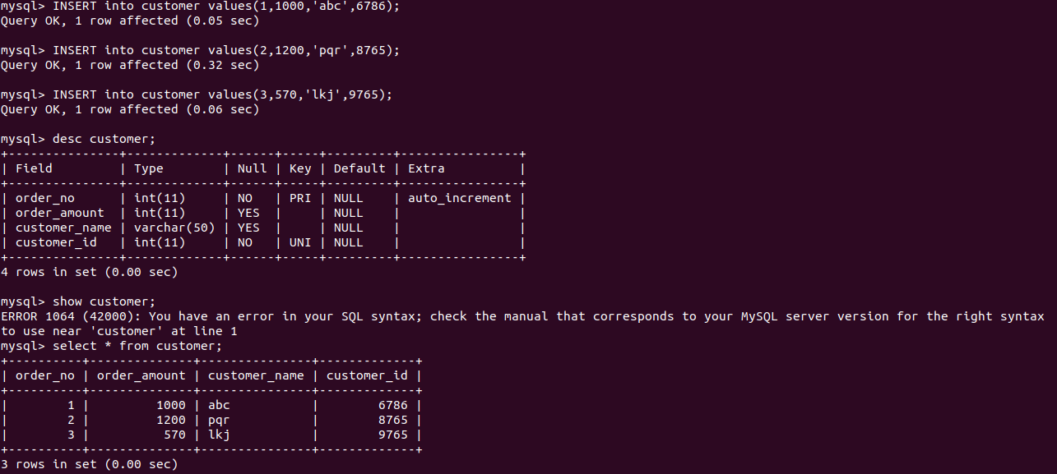

5)Find the sales person have multiple orders.

ANS:

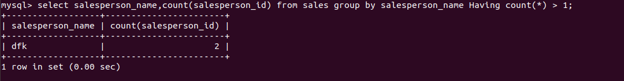

6)Find the all sales person details along with order details

ANS:

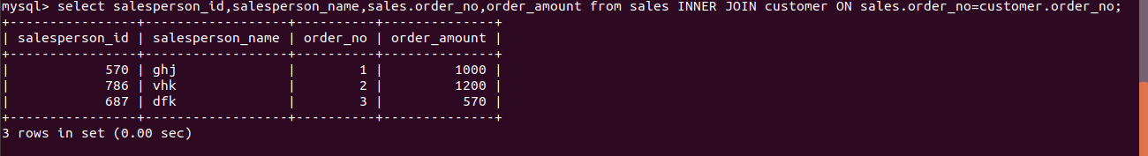

7)Create index

ANS:

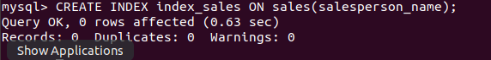

8)How to show index on a table

ANS:

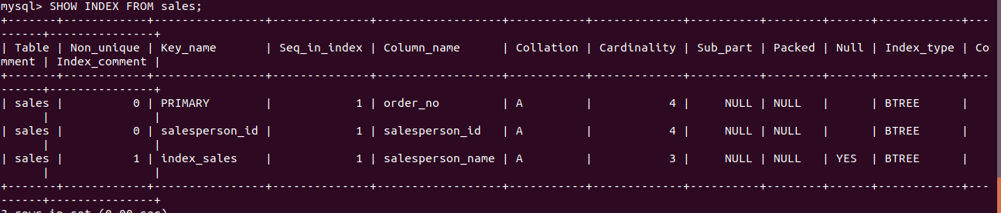

9)Find the order number, sale person name, along with the customer to whom that order belongs to

ANS:

